PRACTISE QUESTION (BRS)

The July bank statement sent by the bank to Parkview Company. This statement shows a balance of cash on deposit at July 31 of $5,000.17. Assume that on July 31, Parkview’s ledger shows a bank balance of $4,262.83. The employee preparing the bank reconciliation has identified the
following reconciling items:
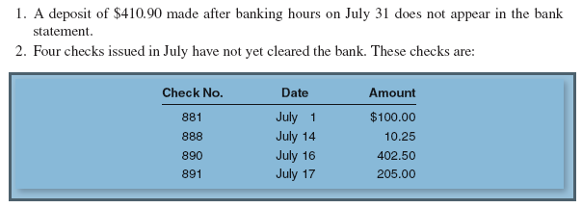
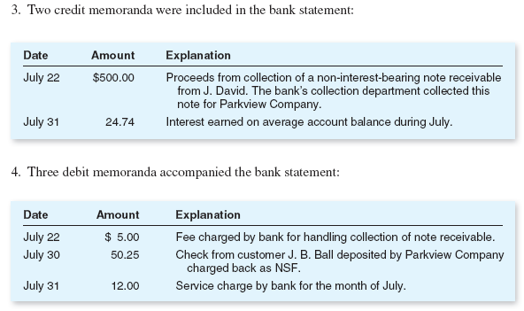
5. Check no. 893 was issued to the telephone company in the amount of $85 but was erroneously recorded in the cash payments journal as $58. The check, in payment of telephone expense, was paid by the bank and correctly listed at $85 in the bank statement.

REQUIRED:

Prepare the adjusted cash book and bank reconciliation statement for the month of July.

Answer

ADJUSTED CASH BOOK
Debit | ($) | Credit | ($)
Un adjusted balance | 4262.83 | Handling fee | 5
Note receivable ` | 500 | Dishonored check (NSF) | 50.25
Interest income | 24.74 | Service charges | 12
 |  | Under cast expense (85 – 58) | 27
 |  | Adjusted balance | 4693.32
Total | 4787.57 | Total | 4787.57

BANK RECONCILIATION STATEMENT
 | ($)
BALANCE AS PER CASH BOOK (Adjusted) | 4693.32 (DR)
+ UNPRESENTED CHEQUES | 717.75
- Deposit after banking hours | (410.90)
BALANCE AS PER BANK STATEMENT | 5000.17 (CR)

